**Project Deliverable 1 Content**

1

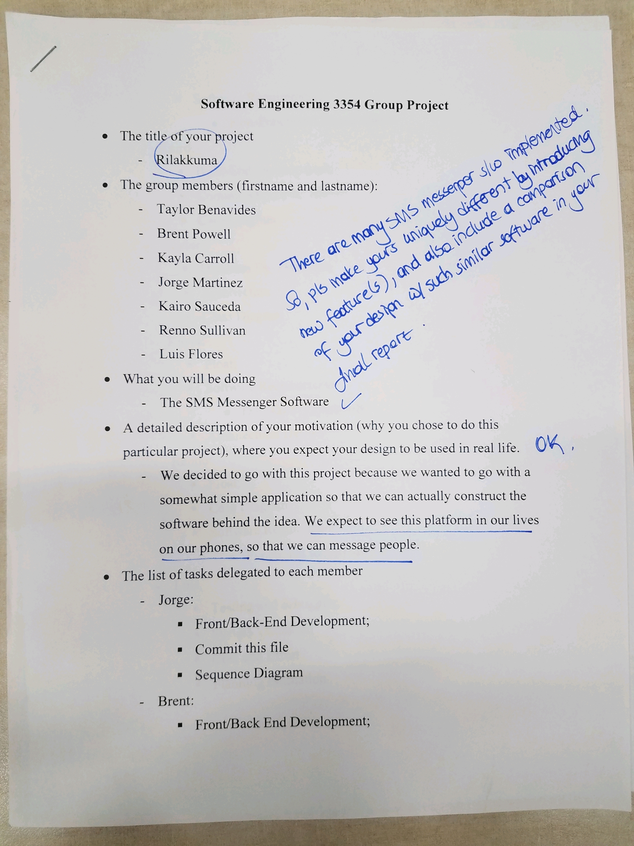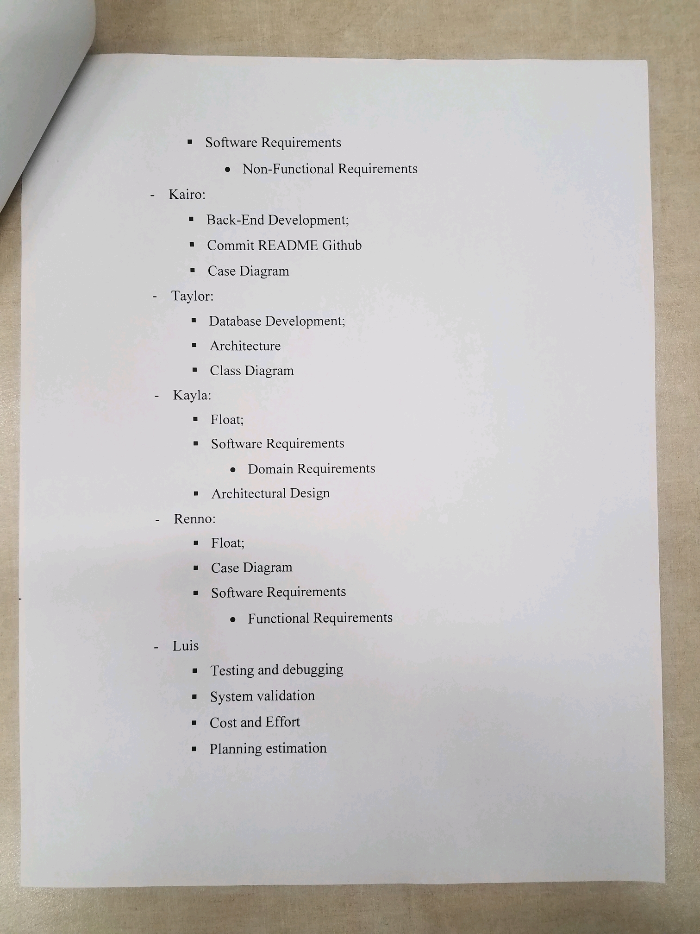

Trying to communicate homework help across text messages is difficult. Explanations oftentimes need the explainer to talk along with what they are writing in order to correctly convey their ideas. Rilakkuma is a web-based application that focuses on sharing a real-time whiteboard between users that can text and talk about it with each other. The users can login using an account and password they provide and connect with other users.

Example:

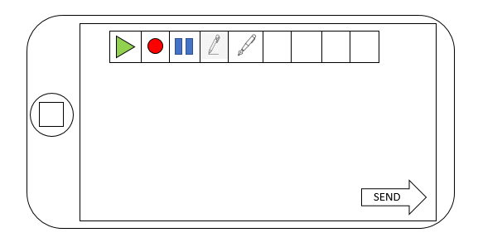

**Project Deliverable 1 Content**

1.1 COMPLETE

1.2 COMPLETE

1.3 COMPLETE

1.4 COMPLETE

1.5 COMPLETE

1.6 COMPLETE

Team project repository URL: <https://github.com/tscott32/3354-TheMorningParty.git>

2. - Taylor: *Delegation of Tasks*

3. - Jorge: *Incremental Software Process Model*

4. - Taylor/Kayla: *Software Requirements*

5. - Renno/Jorge: *Use Case Diagram*

6. - Brent/Kairo: *Sequence Diagrams*

7. - Kayla/Taylor/Brent: *Class Diagrams*

8. - Taylor/Luis: *Architectural Design -* *MVC*

**Project Deliverable 1 Content**

3. [5 POINTS] Which software process model is employed in the project and why.

(Ch 2)

The software process model employed in our project is the incremental development software process model because it allows us to make changes and correct errors incrementally with ease if the latest functionality increment does not meet the project requirements.

4. [15 POINTS] Software Requirements including

4.a.) [5 POINTS] Functional requirements. To simplify your design, please keep your functional requirements in the range minimum 5 (five) to maximum 7 (seven). (Ch 4)

* User must access service i.e., website/mobile application
* User must be able to login/logout
* Search/add/remove contacts
* Ability to send text messages and join calls between mutually added contacts
* Ability to create/edit/delete/share/print “whiteboards”
* Ability to add and edit content to whiteboards

4.b.) [10 POINTS] Non-functional requirements (use all non-functional requirement types listed in Figure 4.3 - Ch 4)

* Product Requirements
  + Usability Requirements

1. Easy and/or simple to use UI
2. Easy to learn application
   * Efficiency Requirements
     + Performance Requirements
3. Minimal Latency (< 12ms)
   * + Space Requirements
4. Text messages < 4MB, whiteboard < 12MB
   * Dependability Requirements
5. Failure Rate < 4%
   * Security Requirements
6. Password specifications
7. Reset password authentication

* Organizational Requirements
  + Environmental Requirements

1. User may be in noisy environment: built-in background noise suppression
   * Operational Requirements
2. Requires space on user’s PC to download application
3. Requires stable wifi
4. Minimum 30kbps

**Project Deliverable 1 Content**

* + Development Requirements

1. Html, CSS, PHP, SQL, javaScript

* External Requirements
  + Regulatory Requirements

1. Function in accordance with TCPA
2. Users agreeing to Terms of Service and Privacy Policy
   * Ethical Requirements
3. Assure users their personal information (address, DOB, any payment methods, etc.) will never be shared
   * Legislative Requirements
     + Accounting Requirements
4. Limit the Use of Storage of Sensitive Data
   * + Safety/Security Requirements
5. Web Application Security Standards

[https://hhs.texas.gov/sites/default/files/documents/doing-business-with-hhs/contracting/web-mobile-minimum-security-standards.pd](https://hhs.texas.gov/sites/default/files/documents/doing-business-with-hhs/contracting/web-mobile-minimum-security-standards.pdf)

5.

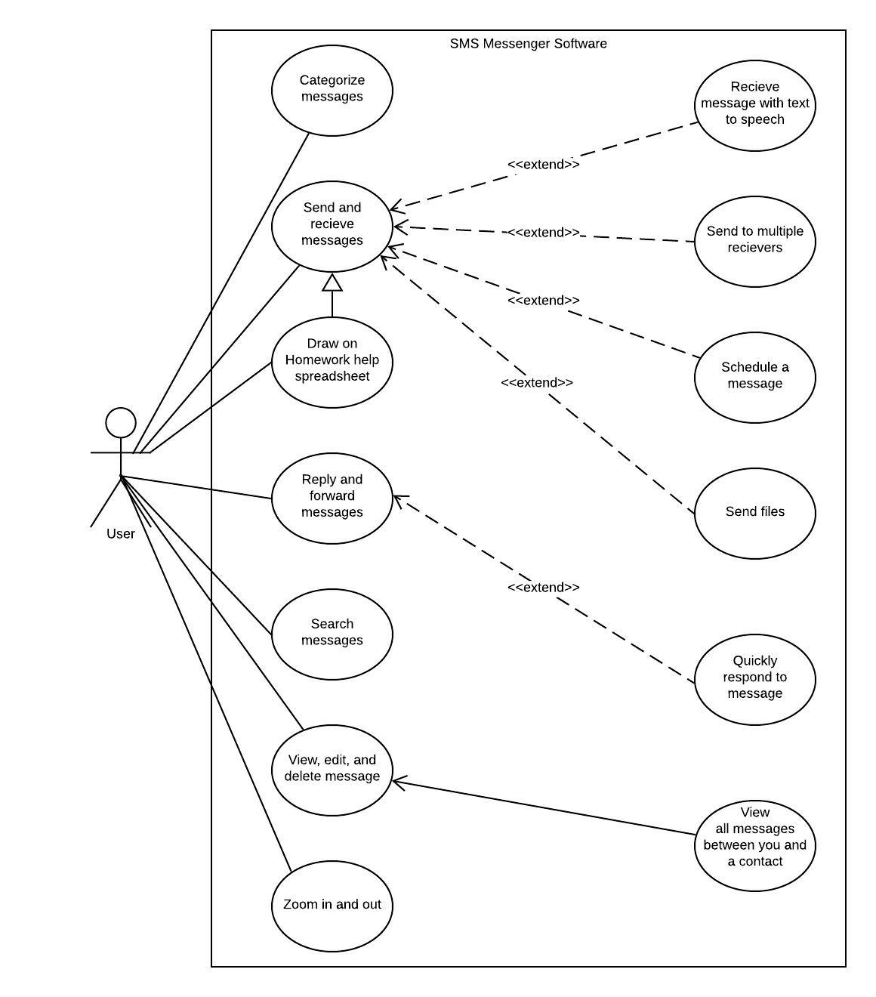

**Project Deliverable 1 Content**

6.

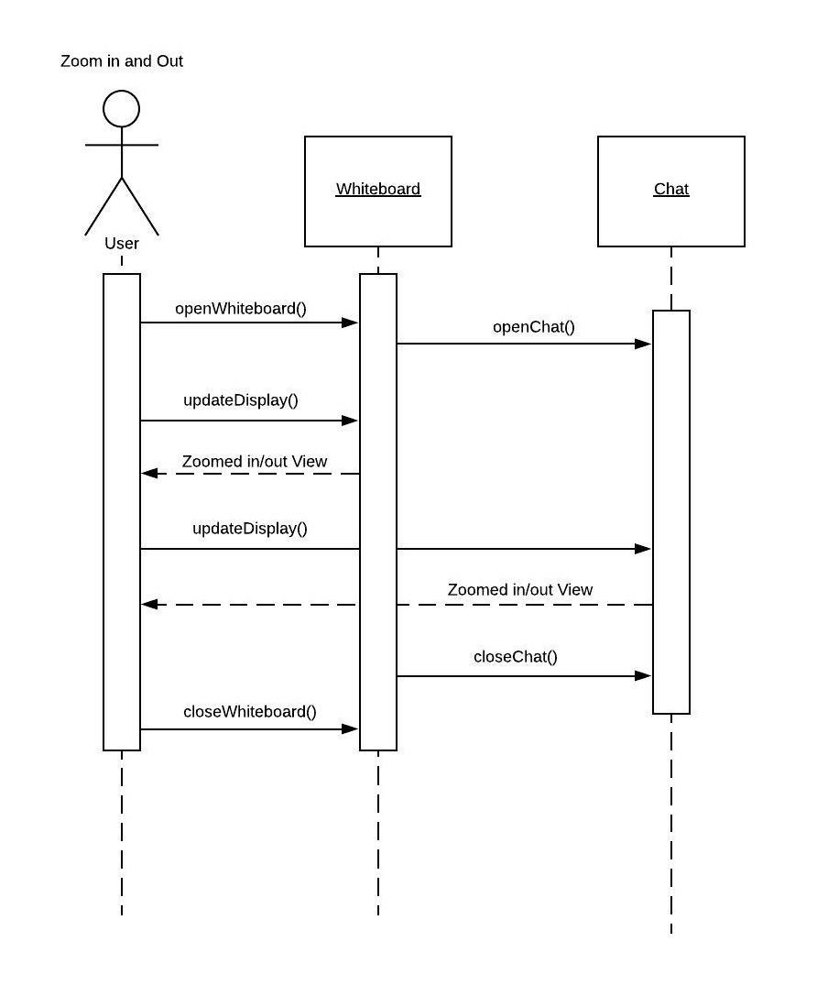

**Project Deliverable 1 Content**

**Project Deliverable 1 Content**

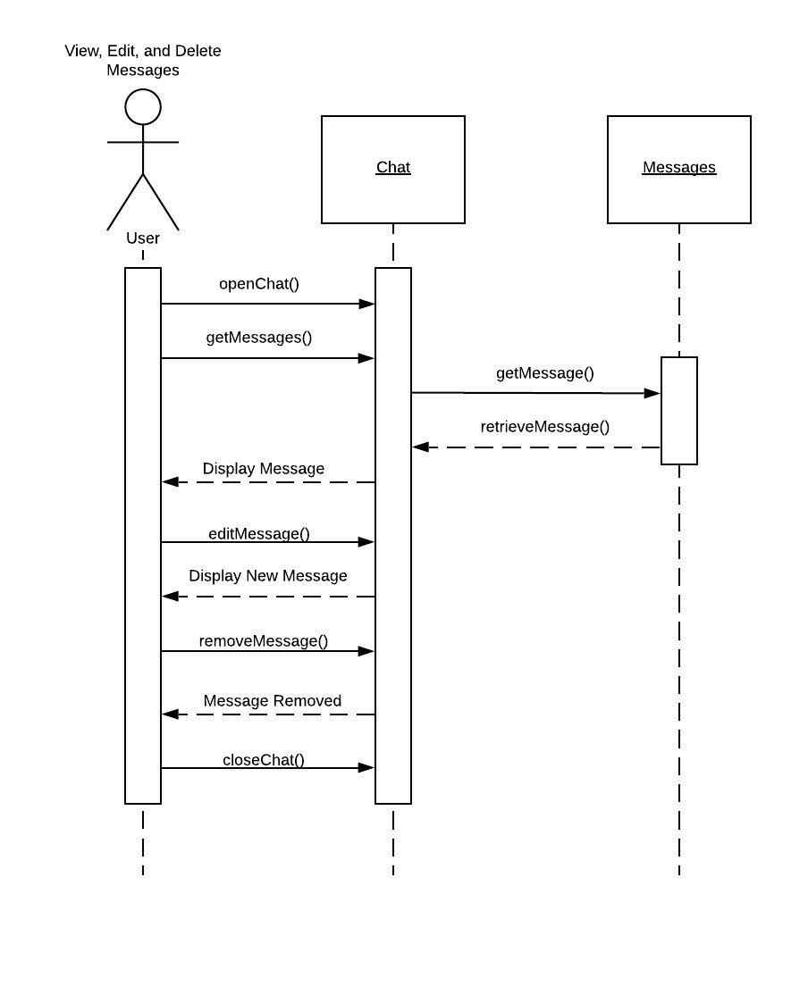

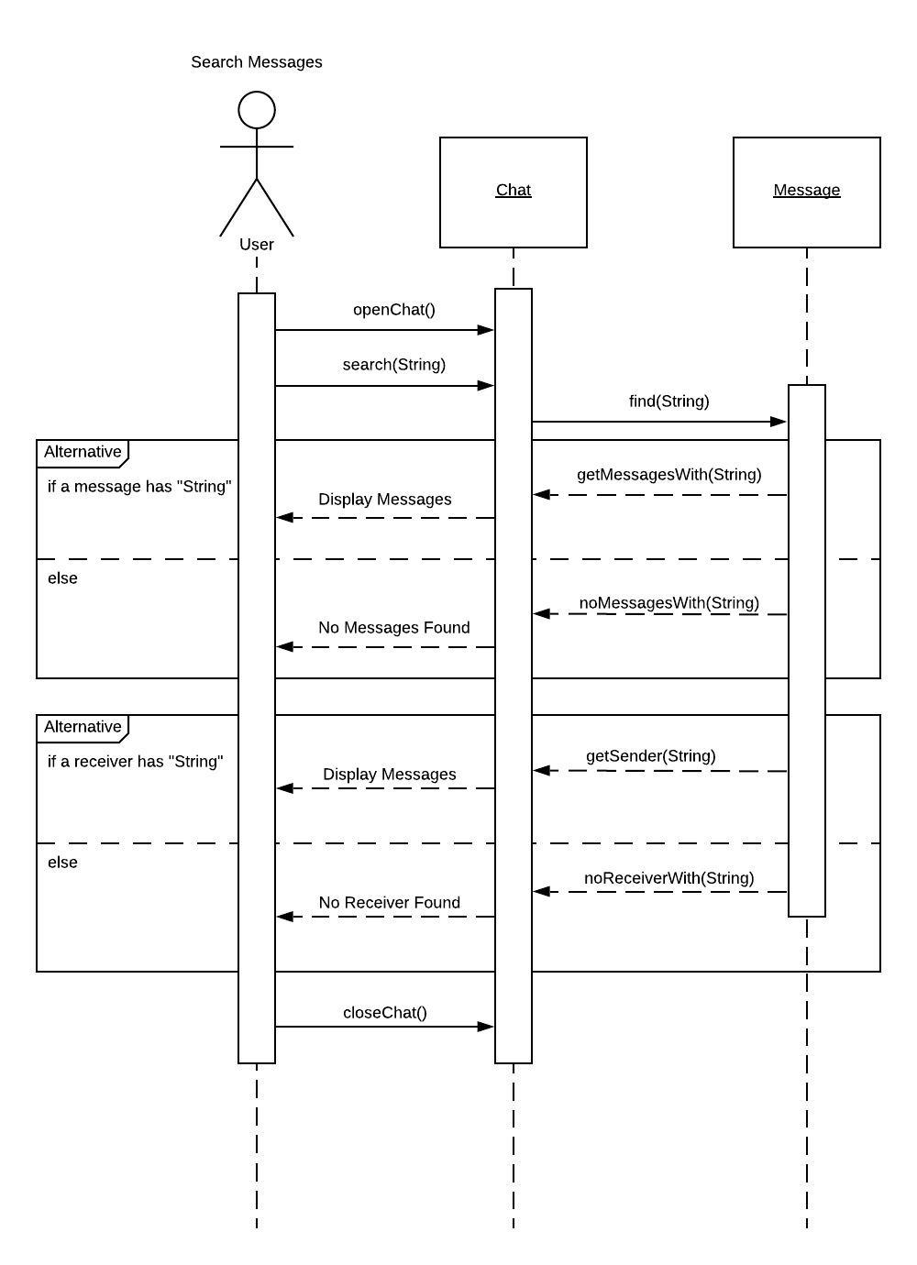

**Project Deliverable 1 Content**

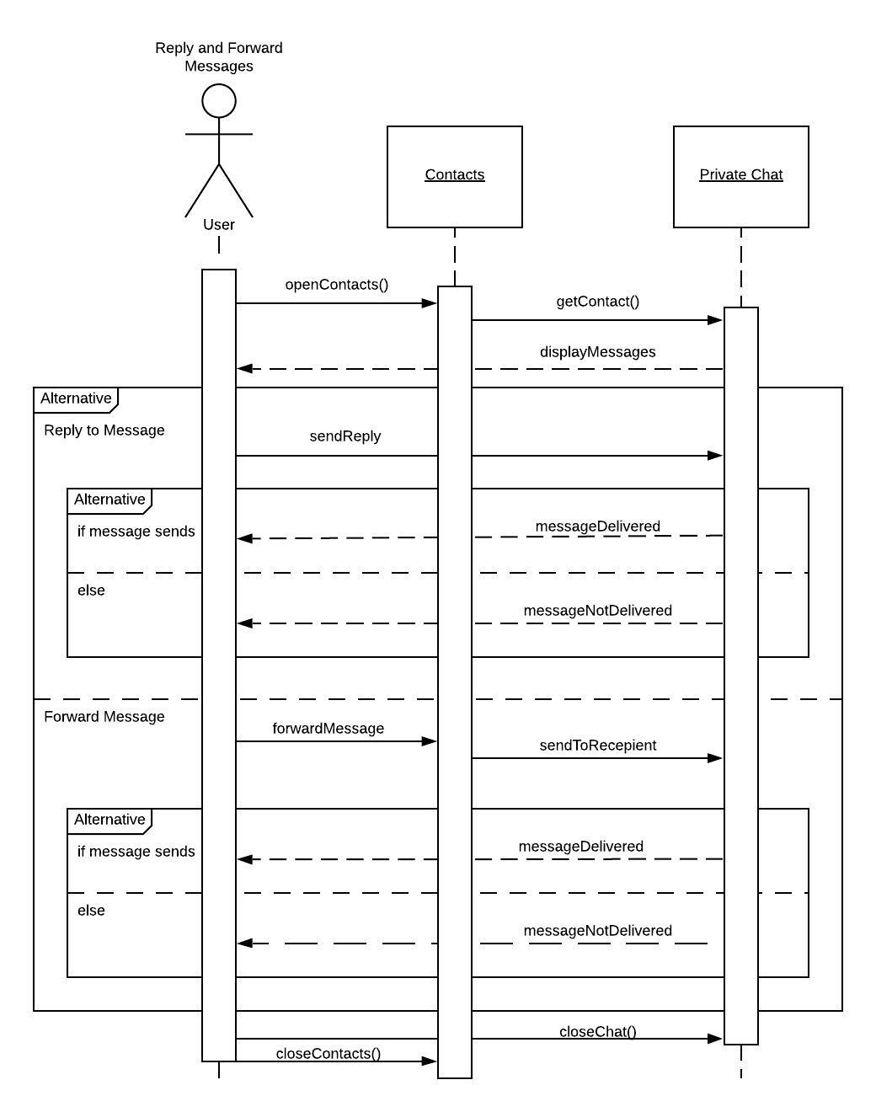

**Project Deliverable 1 Content**

Delete Whiteboard

**Project Deliverable 1 Content**

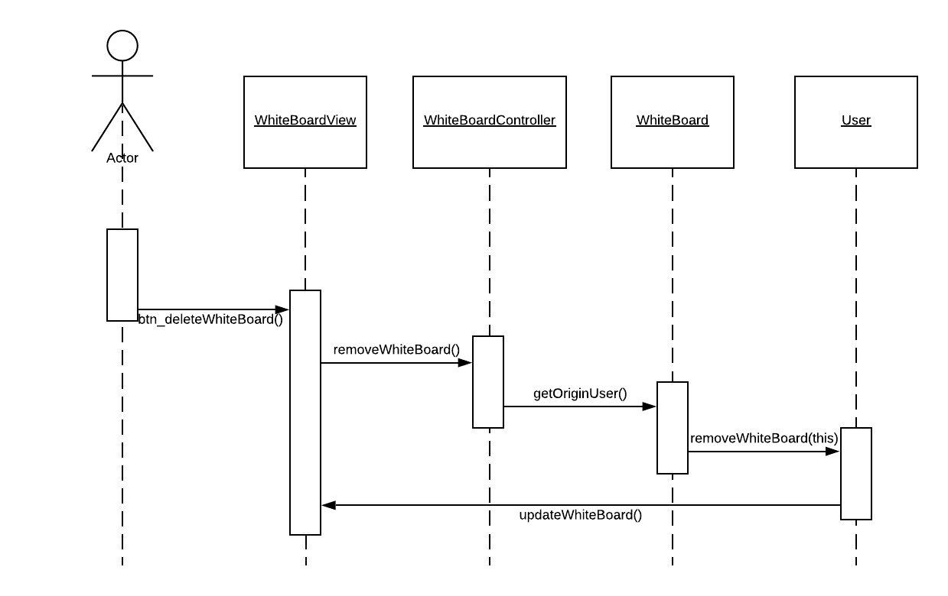

Create Whiteboard

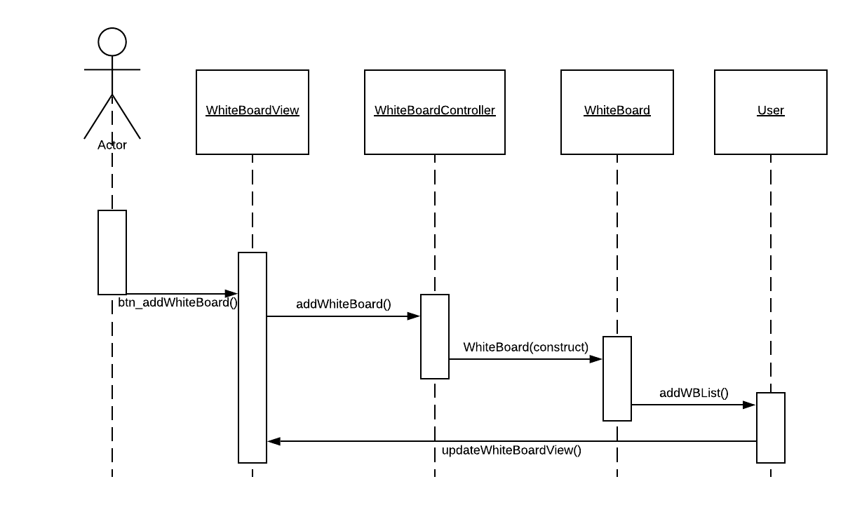

Edit whiteboard

**Project Deliverable 1 Content**

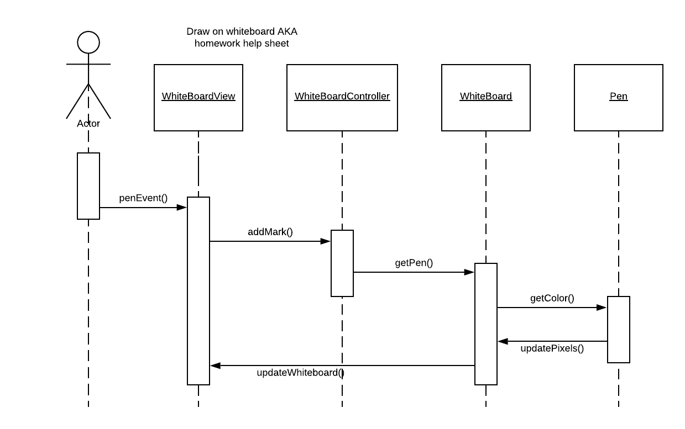

Send and Receive messages

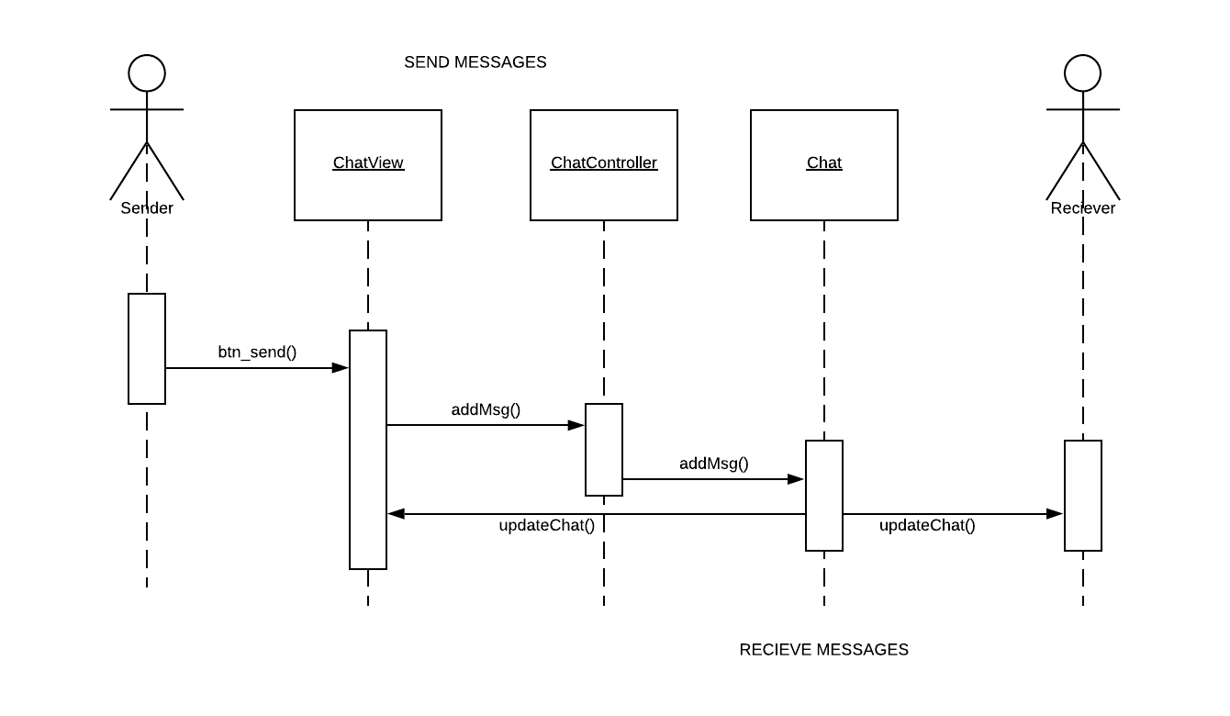

Share Whiteboard

**Project Deliverable 1 Content**

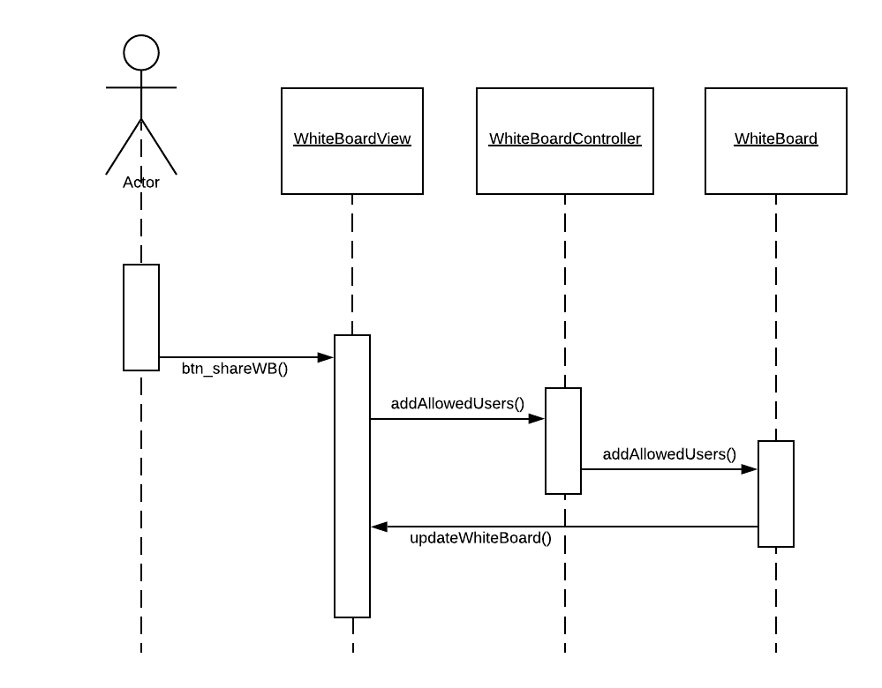

Receive message with text to speech

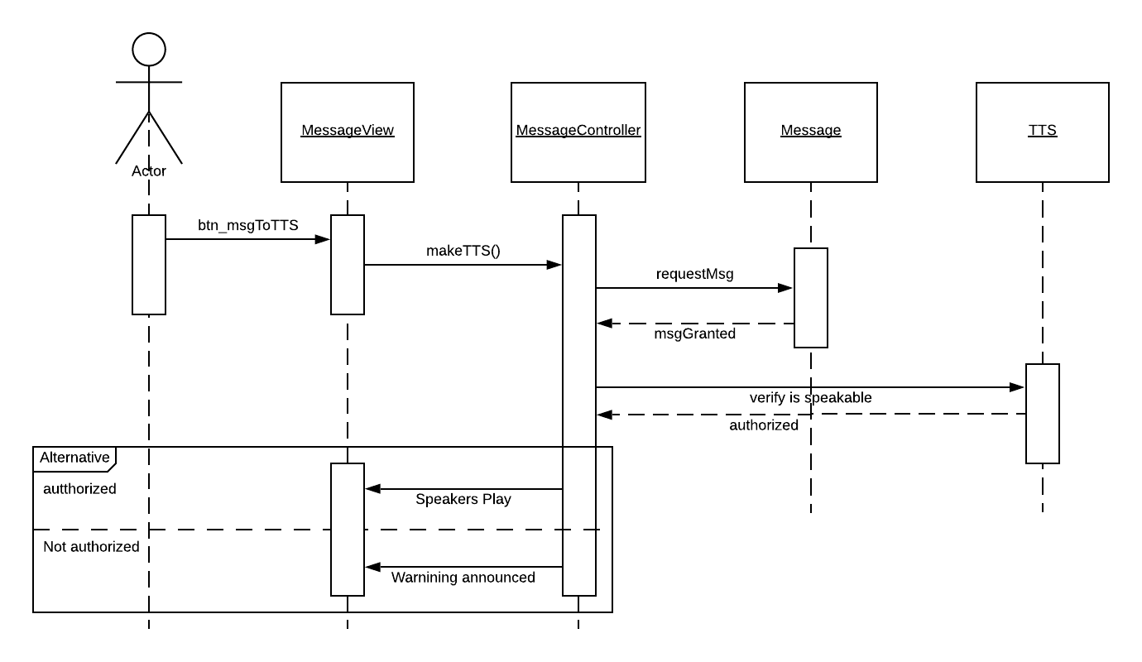

**Project Deliverable 1 Content**

Schedule message

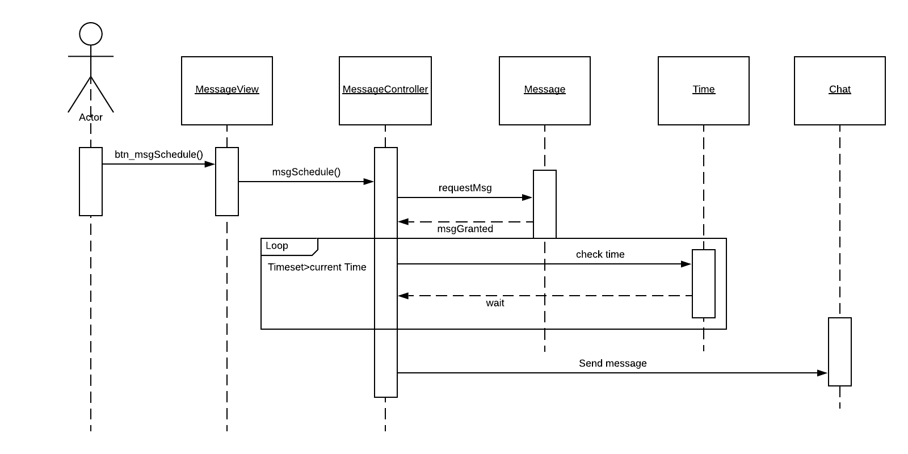

7.

**Project Deliverable 1 Content**

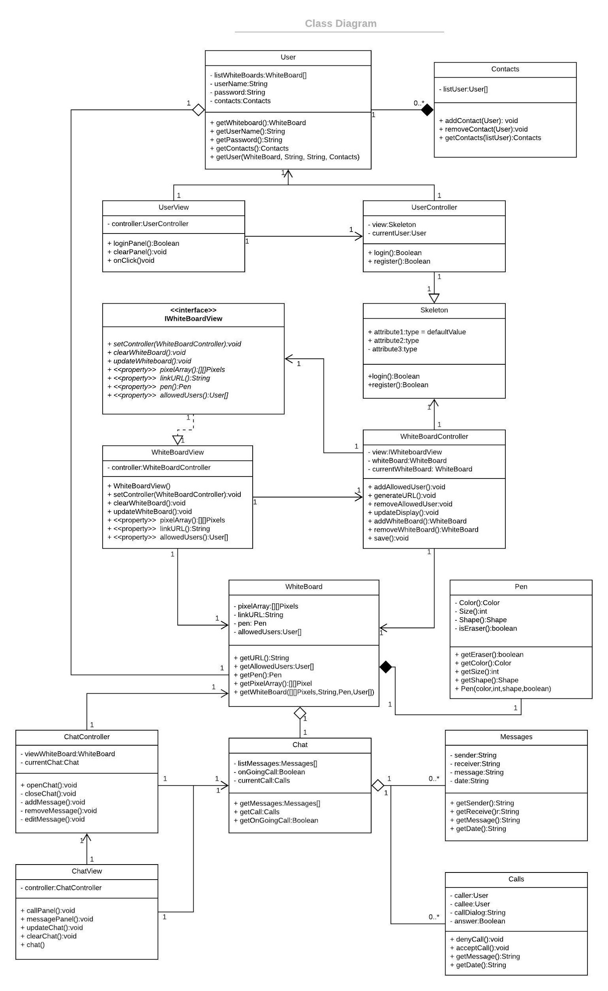

8.

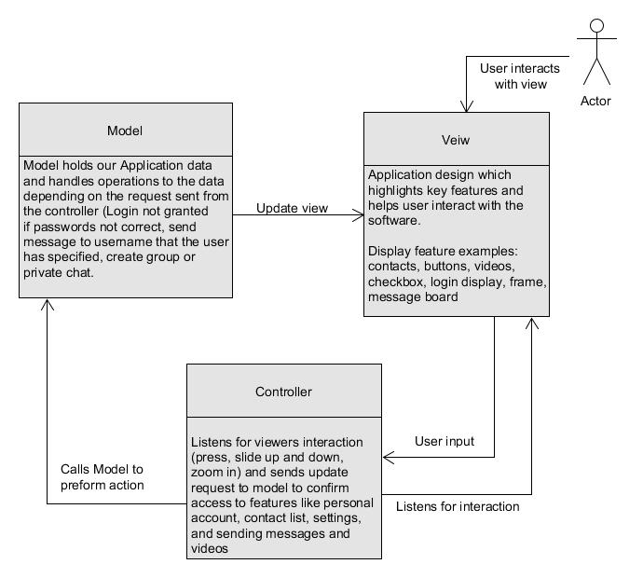

**Project Deliverable 1 Content**